<PROJECT & RELEASE>
Design Documentation
Prepared by <TEAM>:
- Mitchell Derby
- Pedro Vega
- Beltran Caliz
- Quang Vu

Summary 3
Requirements 4
Domain Model 5
System Architecture 6
Subsystems 7
Subsystem #1 (name the subsystem with a name that expresses its use within the context of the application) 7
Subsystem #2 7
Sequence Diagrams 8
Appendix 9

Summary
This section provides a brief overview of the project.
- Describe your high-level architectural, i.e. subsystem, design.
- Give a rationale for the major design choices
- Tie back to specific requirements statements
- Outline how the design reflects a balance among competing design principles such as low coupling and etc

Domain Model

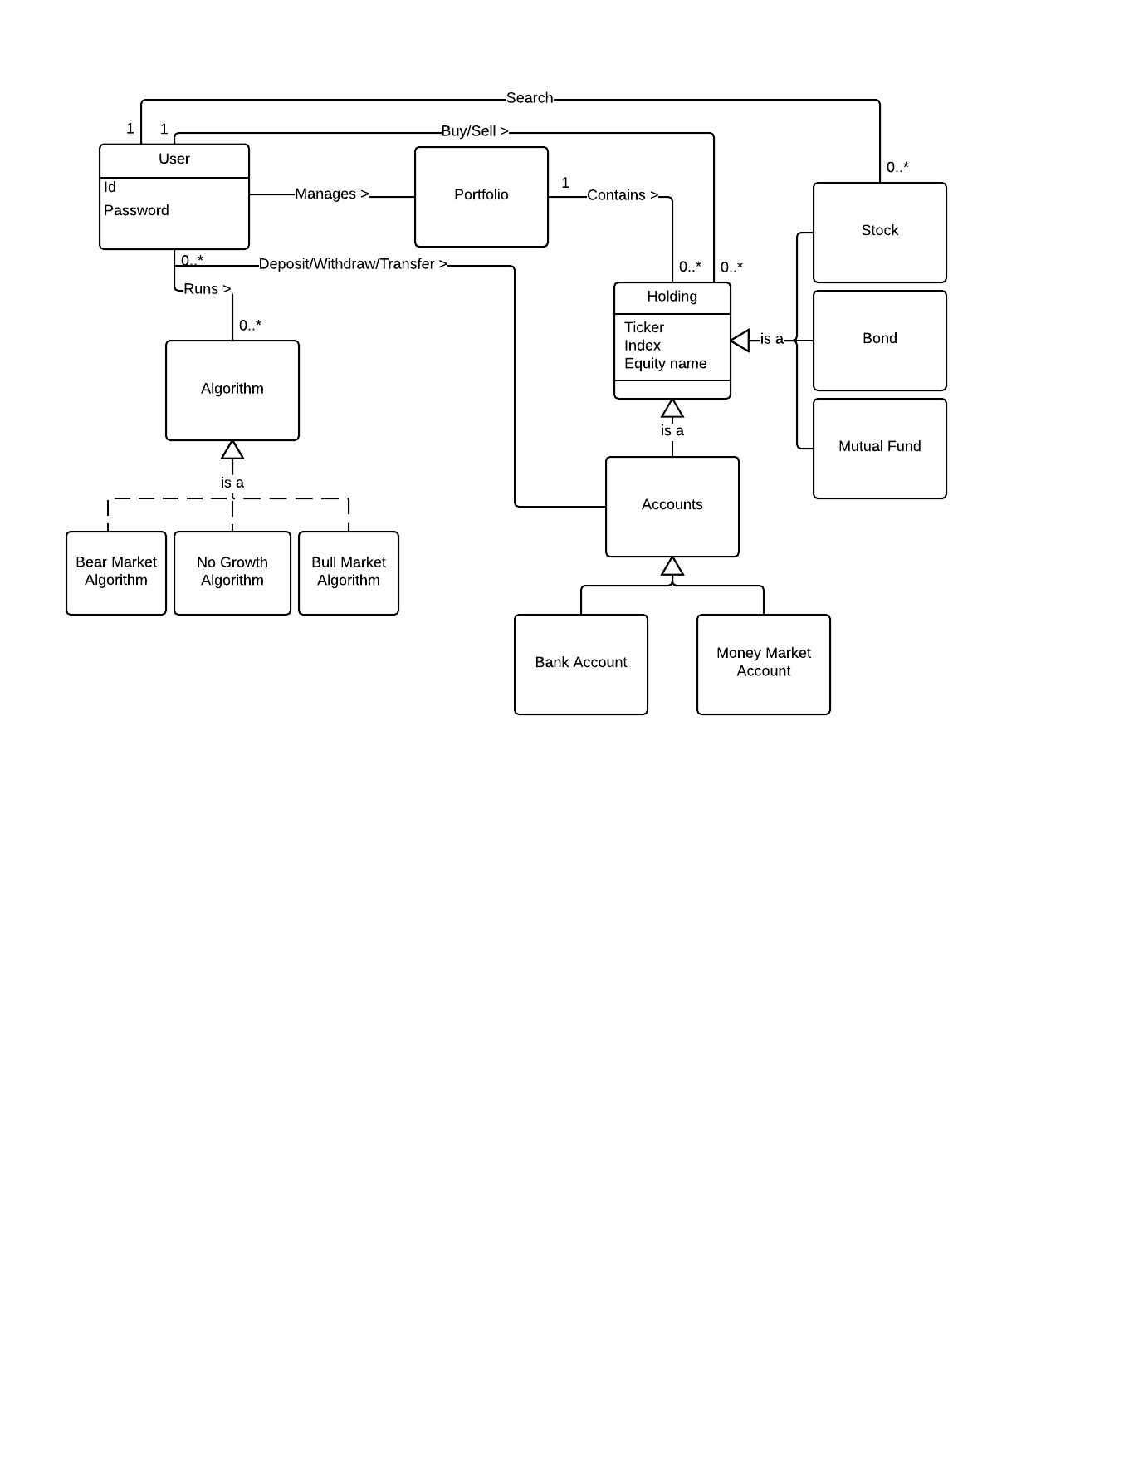
Set of UML Class Diagrams
Show the main classes and interfaces in your design, along with inheritance (generalization), association, aggregation, and composition relationships.
- Include multiplicity and role indicators as you deem appropriate to make the diagrams clear but not cluttered.
- DO NOT include state or method information (that information is captured in the CRC cards as described below).
- Indicate pattern participation using stereotypes (i.e., in guillemets « and »).
Rarely can you document your system, in a way that the reader can physically see and intelligently understand, using a single diagram. You will need several class diagrams at different levels of abstraction and for different subsystems to completely document your design. A top-level diagram may be just subsystems, or may be a mix of classes and subsystems. Next level diagrams would detail the subsystems.

Class-Responsibilities-Collaborators
Subsystems
This section provides detailed design for specific subsystems described in the system architecture.

Subsystem #1 (name the subsystem with a name that expresses its use within the context of the application)
This section provides a description and UML class structure diagrams that model subsystem #1. You should also describe dynamic behaviors that are primarily located within this subsystem using sequence diagrams and a narrative to explain the behavior.
For each design pattern that you are using within this subsystem complete a design pattern usage table. If a design pattern cuts across the boundary of subsystems, place the pattern usage table in the section for the subsystem that holds the majority of pattern participants.
Generic GoF Design Pattern: | PATTERN
System Context Pattern: | PROJECT CONTEXT
Participants:
- Participant-A | - MyClassA – presents blah, blah, blah...
- Participant-B | - MyClassB – presents blah, blah, blah...
Requirements Covered: | R2, R47, R42

Subsystem #2
This section provides a similar description and diagrams the model describing subsystem #2.

Sequence Diagrams
This section contains the sequence diagrams and narrative text that describe the operation of major features in the application. At a minimum, you should document any features that are listed in the design project problem statement. You may also decide that other features require documentation.
Appendix
This section provides fine-grained design details for all of the classes in your design. You will capture this information using the CRC (Class-Responsibilities-Collaborators) card format below.
Class: MyClass1
Responsibilities: ...
Collaborators: ...
Users: ... | Used by: ...
Author: ...

